Use Cases

Simple and extended use cases of the system

Sanjay Dookhoo

2017

# Extended Use Case

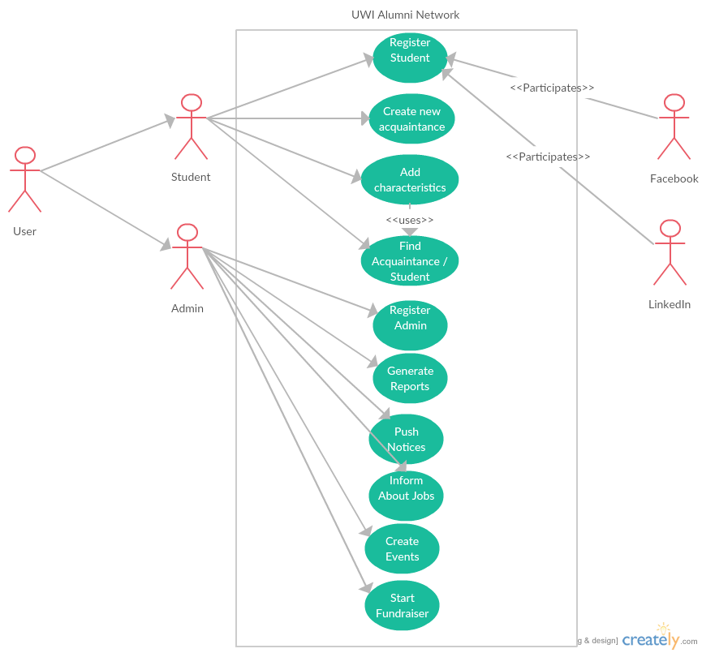

# Simple Use Case - Add Characteristics

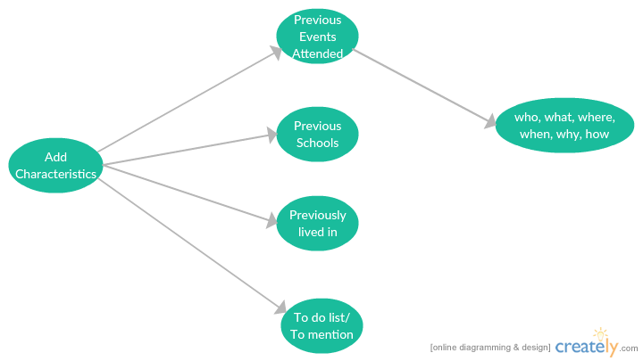

# Simple Use Case – Generate Reports

